*5.2 Investigation*

**Justification of Planned Research**

Now that I’ve identified the main goals and requirements for replacing Investor Centre’s paper-based system, I need to look more closely at how the current system works and what each stakeholder needs. This will help me design a solution that really meets the company’s needs. I’ll use a few different research methods to do this:

* **Interview with the Manager/Owner**  
  First, I’ll interview Investor Centre’s manager/owner. This will help me understand how they currently handle client records, transactions, and any problems with the current system. I’ll ask questions to learn what they’d want in a new system and find out about any day-to-day challenges they face. To make sure I get useful answers, I’ll prepare questions in advance.
* **Employee Questionnaire**  
  I’ll also create a questionnaire for employees. This will help me understand how they feel about the paper-based system, including any issues they have with keeping records, managing client info, or handling trades. Using a simple scale (from 1 to 5) will make it easy to analyse their responses and see any patterns.
* **Observation of Daily Operations**  
  Finally, I’ll observe the daily operations at Investor Centre. Watching how employees work with the current system will help me see problems first hand and understand exactly where it slows them down or causes errors. I’ll take notes and organize them into a table to track each issue I find.

**Interview**

|  |  |  |  |
| --- | --- | --- | --- |
| Question | Answer | Follow-up Question | Conclusion |
| How would you describe the current system used at Investor Centre? | The system we have in place is very outdated. We’re still relying on paper files for almost. It’s hard to manage large amounts of data manually, and we often have issues with lost or misplaced documents. Security is a huge concern as well since everything is on paper. | What are some specific challenges that come from using this paper-based system? | The current paper-based system is clearly inefficient and vulnerable. A digital system would streamline operations, reduce the risk of errors, and improve accessibility. |
| What are some specific challenges that come from using this paper-based system? | The biggest issue is the time it takes to find information. Searching through piles of paper files is slow, especially when clients are looking for immediate responses. Another challenge is data redundancy; we often end up entering the same information more than once, which causes confusion and mistakes. | How would a digital system improve this process? | Transitioning to a digital system would drastically improve the speed and accuracy of handling client and financial data, reducing the risks associated with the current paper-based process. |
| How do you currently handle client records and financial data? | We keep everything in physical files: client information, transaction records, and investment details are all written down or printed on paper. When clients make trades or update their portfolios, we manually record the information, which can sometimes lead to duplication or data entry errors. | How could a digital platform help with tracking investments? | Real-time tracking of investments and trades would significantly reduce the workload on staff and improve overall efficiency. It would also give clients more timely information, leading to better service. |
| How would a digital system improve this process? | A digital system would eliminate the need for paper records and make searching for information faster. We could easily store and retrieve client data using a database, and we wouldn’t have to worry about redundant or missing data. Automation could also help prevent errors when entering new transactions or client details. | How would a digital system address these security issues? | A digital system would offer much stronger data protection and minimize the risk of unauthorized access or data loss. |
| How do you track and manage client investments and trades? | Right now, we manually track investments on paper, including trade amounts, buy/sell prices, and the client’s portfolio balance. Every time a trade is made, I have to write it down in a ledger and update the client’s record by hand, which is very time-consuming. | How do you think a new digital system would improve the client experience? | Improving the client experience with quicker and more accurate responses is a key advantage of moving to a digital system. |
| How could a digital platform help with tracking investments? | A digital system would automate the entire process. It could provide real-time updates on trades and balances, allowing us to easily track profits and losses without the need to manually calculate everything. Integration with live market data would allow us to make quicker and more informed decisions. | What are the main challenges you foresee in transitioning to a digital system? | While there may be challenges during the transition, proper training and careful data migration will ensure that the digital system can be successfully implemented. |
| How do you currently manage security and data protection? | Security is a big concern. Since everything is on paper, it’s easy for records to be lost or stolen. We also don’t have a proper way of controlling who has access to sensitive data. Files are kept in locked cabinets, but there’s always a risk that someone could access confidential information by mistake. | How would a digital system address these security issues? | With a digital system, we could implement secure logins with different access levels for staff. Sensitive data could be encrypted, and we could restrict access to certain records based on user roles. This would greatly improve data security and protect client information. |
| How would a digital system address these security issues? | With a digital system, we could implement secure logins with different access levels for staff. Sensitive data could be encrypted, and we could restrict access to certain records based on user roles. This would greatly improve data security and protect client information. | How do you think a new digital system would improve the client experience? | Clients would benefit from faster responses and real-time access to their portfolios. |
| What are the main challenges you foresee in transitioning to a digital system? | One of the challenges will be training staff to use the new system. Since some of our team is not very tech-savvy, there may be an adjustment period. Another challenge is ensuring that all data is properly transferred from the paper records to the new digital system without losing any important information. |  |  |

**Interview Analysis**

Interviewing Investor Centre’s manager gave me valuable insights into the day-to-day challenges the company faces with their current paper-based system. This highlighted the need for a digital system that could streamline processes, enhance data security, and provide easier access to client records and trade information.

From the interview, it became clear that the current system is outdated and inefficient, especially when managing large volumes of data. Searching through physical files is time-consuming and error-prone, leading to issues with data redundancy and misplaced documents. Security was another major concern, as paper records are vulnerable to theft or loss, and there is limited control over who can access sensitive information.

The manager also expressed frustration with how manual data entry creates delays, especially when clients request immediate updates on their accounts. A digital solution would help overcome these issues by providing real-time updates, improving response times, and ultimately enhancing the client experience.

To address these problems, I proposed a computer-based system that would allow for secure data storage, easy retrieval of client and trade records, and automated backups to prevent data loss. Additionally, a digital system could implement user logins with access levels, ensuring only authorized staff can view or edit sensitive data. This interview made it clear that transitioning to a digital system could significantly improve efficiency, security, and client satisfaction at Investor Centre.

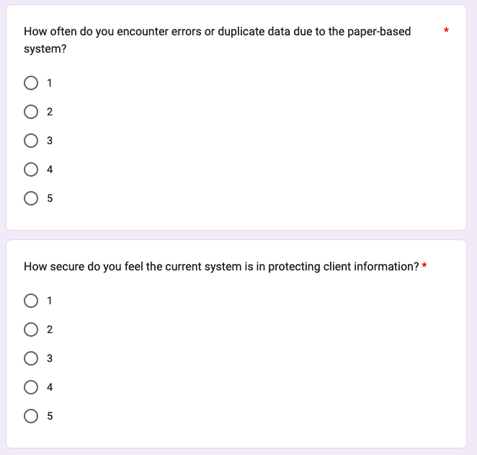**Questionnaire**

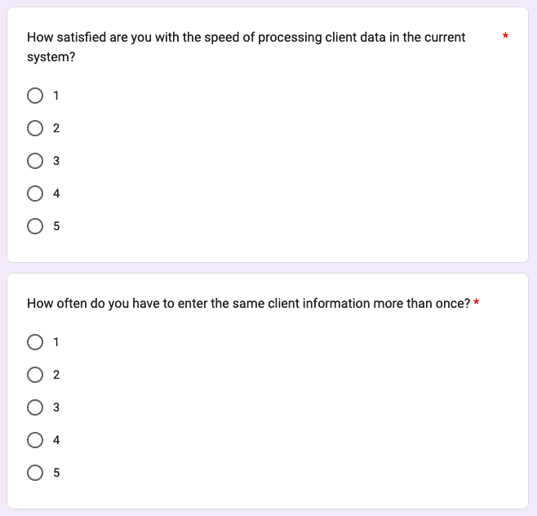

Questionnaire Analysis

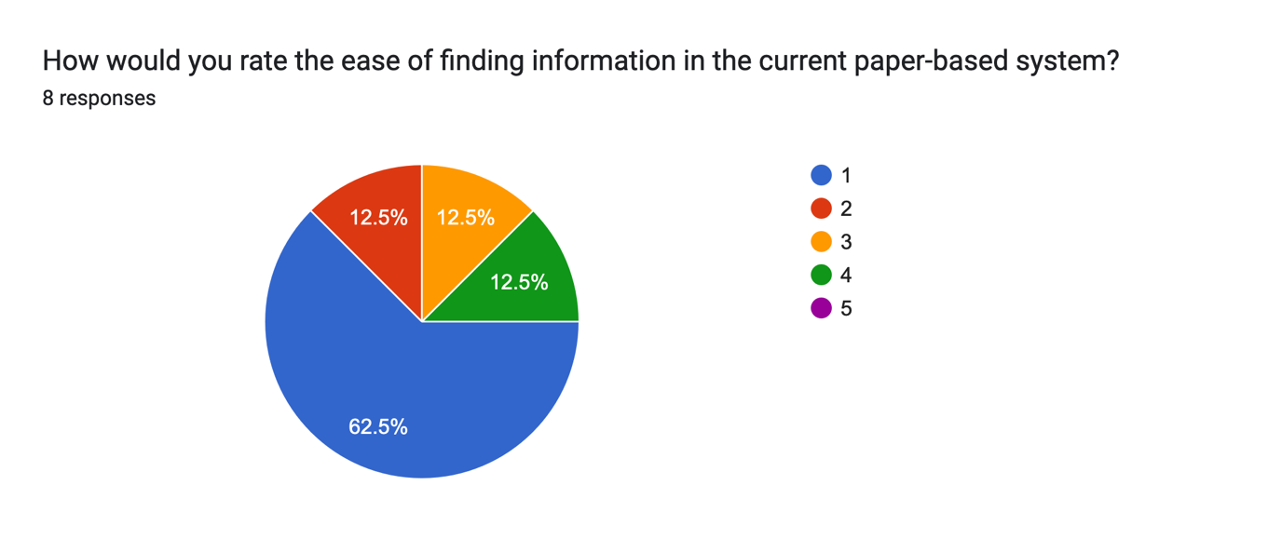[Fig1]

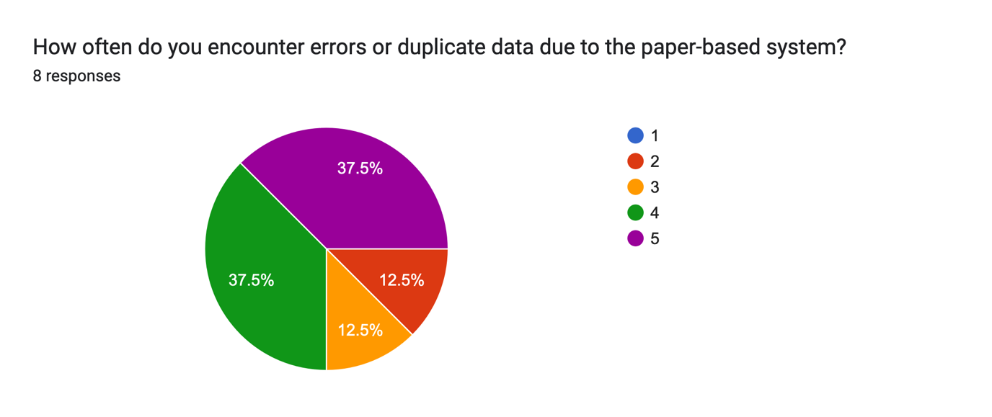

[Fig2]

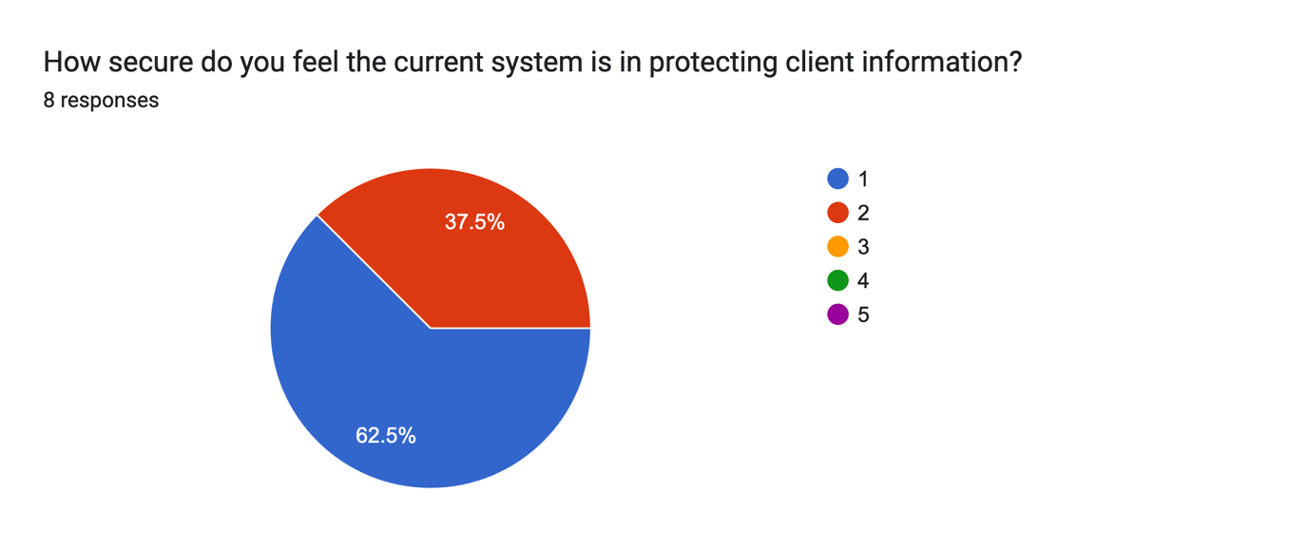

[Fig3]

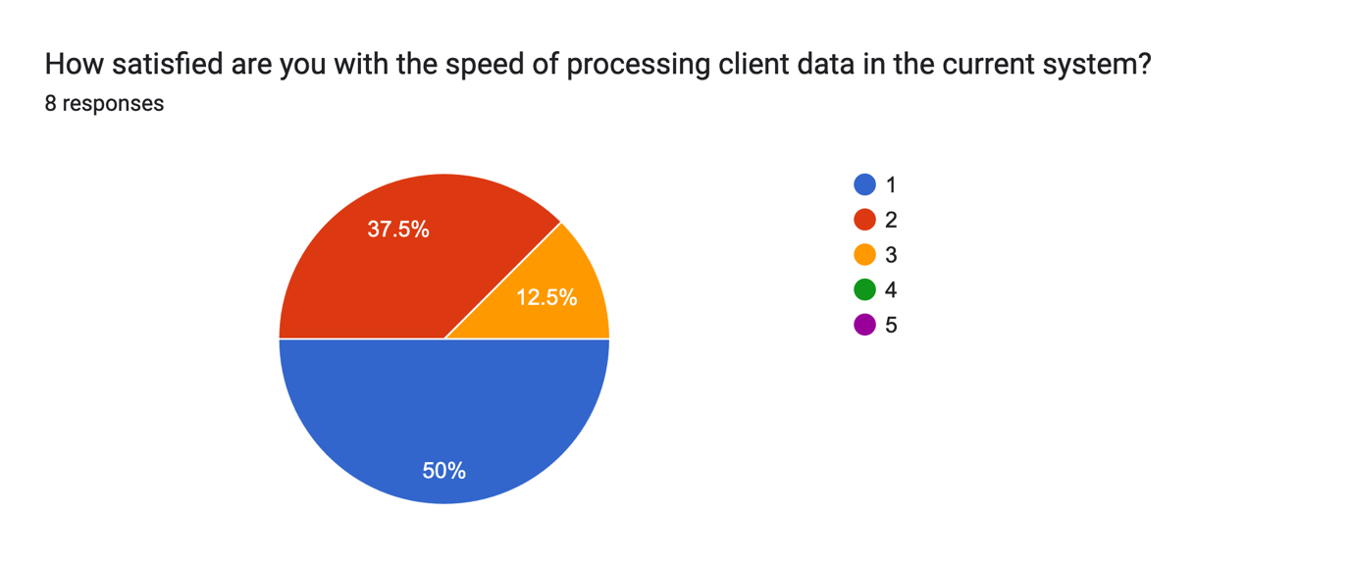

[Fig4]

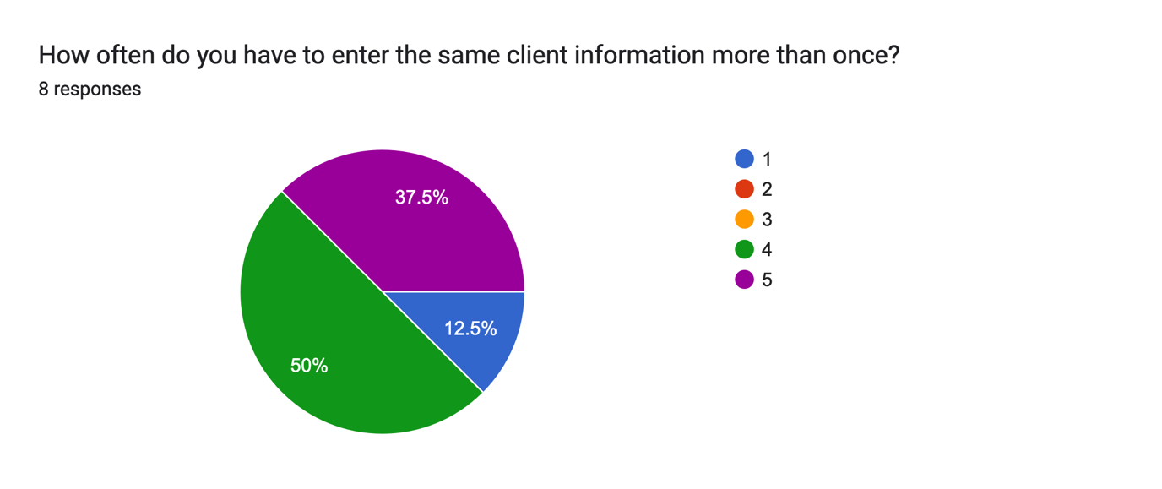

[Fig5]

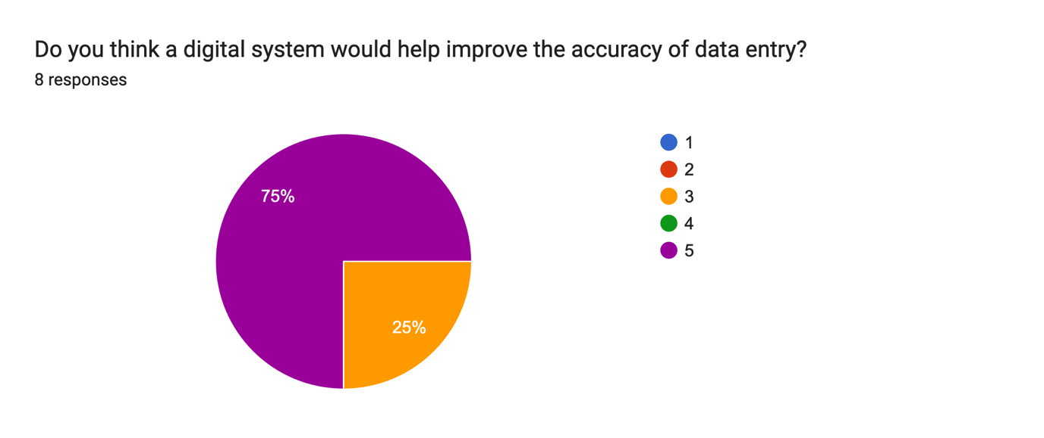

[Fig6]

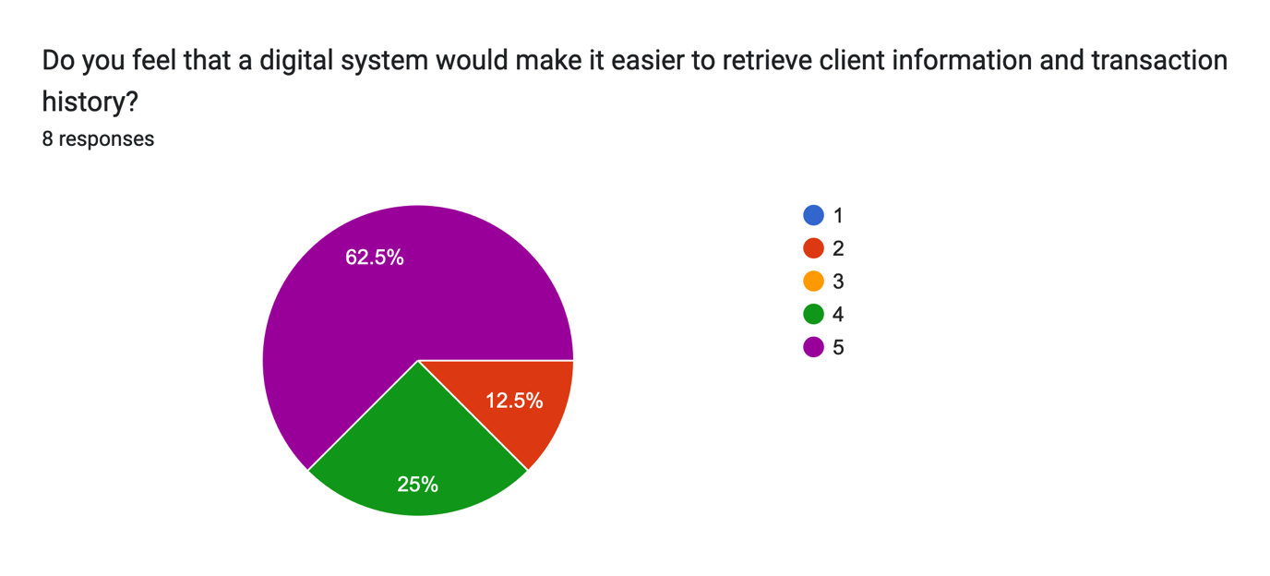

[Fig7]

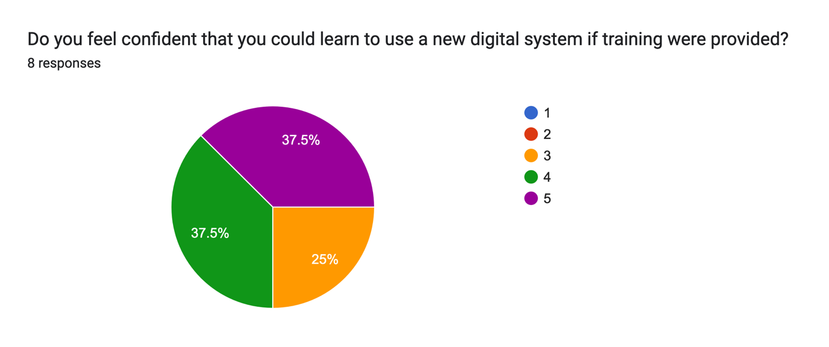

[Fig8]

**Finding Information in the Current System**Most people find it very difficult to locate information in the paper-based system, with 62.5% giving it a 1 out of 5. This shows that finding information is a big problem, and most employees are unhappy with how hard it is to access records.

**Frequency of Errors or Duplicate Data**Errors and duplicate data are frequent issues, with 75% of responses rating this as a 4 or 5 out of 5. This means the current system often leads to repeated information or mistakes, causing confusion and slowing down work.

**Security of the Current System**The majority of employees (62.5%) rated the system’s security at a 1 out of 5, showing they don’t feel confident in its ability to keep client information safe. This indicates that security is a major concern with the paper-based system.

**Satisfaction with Processing Speed**  
Half of the respondents rated processing speed at a 1 out of 5, and another 37.5% rated it a 2, showing that most people are frustrated with how slow the current system is when managing client data.

**Frequency of Re-entering Client Information**Re-entering the same information happens a lot, with 50% rating it as a 4 and 37.5% rating it as a 5. This shows that redundancy is a common problem in the paper system, leading to wasted time and errors.

**Expected Impact of a Digital System on Data Entry Accuracy**75% of employees rated the expected impact of a digital system on accuracy as a 5 out of 5, indicating strong confidence that switching to digital would improve accuracy and reduce errors.

**Ease of Retrieving Client Information in a Digital System**  
Most respondents feel that a digital system would make it much easier to retrieve information, with 62.5% rating this as a 5 out of 5 and 25% rating it as a 4. This suggests that a digital solution would solve one of the biggest problems with the current system.

**Learning Digital System**  
37.5% of employees feel very confident (5 out of 5) that they could learn a new system, and another 37.5% rate their confidence as a 4. This shows that with some training, most employees feel ready to switch to a digital system.

**Conclusion**  
The responses show that the current paper-based system is inefficient, with major issues like difficulty in finding records, frequent errors, and poor data security. There’s a clear preference for a digital system, which employees believe would speed up work, improve accuracy, and make information more secure. Most employees also feel confident they could learn a new digital system with the right training.

**Observation**

To understand how the paper-based system works at Investor Centre, I watched a typical day in the office. Right away, I saw that employees often struggled to find specific client records, especially when clients needed quick updates. Searching through paper files took a lot of time, and since there were so many files in a small space, it was easy for documents to get misplaced.

I also noticed that every transaction had to be recorded by hand, which sometimes led to mistakes or missed entries, especially when things got busy. Employees often had to double-check each other’s work to avoid errors, which took even more time. The process seemed stressful, as there was no automated way to catch mistakes.

Client records were stored in a cabinet without a proper organization system, which made it easy to lose important documents. Since everything was on paper, there

was no way to restrict access to sensitive information, meaning anyone could accidentally see client data.

Overall, the paper-based system was simple but caused a lot of stress for employees due to how slow and unorganized it was. These observations showed that a digital system could make things faster, more secure, and easier to manage.

**Stakeholders**

* **Employees**  
  Employees are the main users of the system. They will be responsible for entering and updating client information and financial transactions. They should be able to log in to the system, view client portfolios, and track trade histories, ensuring they can provide timely responses to client inquiries.
* **Clients**  
  Clients will indirectly interact with the system when they request updates on their investments or trades. Although they won’t directly access the system, the system’s data accuracy and security are essential for maintaining trust and providing quick updates when needed.
* **Owner/Manager**  
  The owner or manager will have access to all areas of the system. They should be able to view, edit, and analyze data on clients, trades, and employee records.

**Current Data Inputs**

* **Client Name**  
  Clients provide their full names when creating an account or making a transaction.
* **Client Contact Information**  
  Clients provide contact details like email or phone numbers to enable follow-ups or urgent updates.
* **Transaction Details**  
  Each trade includes details such as currency pair, trade amount, and the buy/sell price.
* **Employee Information**  
  Employee names, and contact details are recorded for scheduling and wage calculations.

**Current Processes of Data**

* **Storing Client and Trade Information**  
  All client and transaction data are recorded in files, which are stored in a central filing cabinet.
* **Updating Trade Records**  
  Each transaction must be manually logged and updated when clients make new trades or request changes.

**Current Data Outputs**

* **List of Clients and Trades**  
  A printed list of all clients and recent trades is kept in the cabinet for quick reference.

**Current System Limitations**

* **Difficult Data Retrieval**  
  Finding specific client information or transaction records requires manual searching, which is time-consuming and prone to errors.
* **Lack of Data Backup**  
  There are no backups for client records, meaning data could be lost due to damage or misplacement.
* **Low Data Security**  
  The paper-based system has no encryption or access control, making sensitive client information vulnerable.

**Desk Research**

**Meta Trader 5**

I researched how competitors have modernised their systems to find ideas and implement them into my system to be competitive with other local businesses.

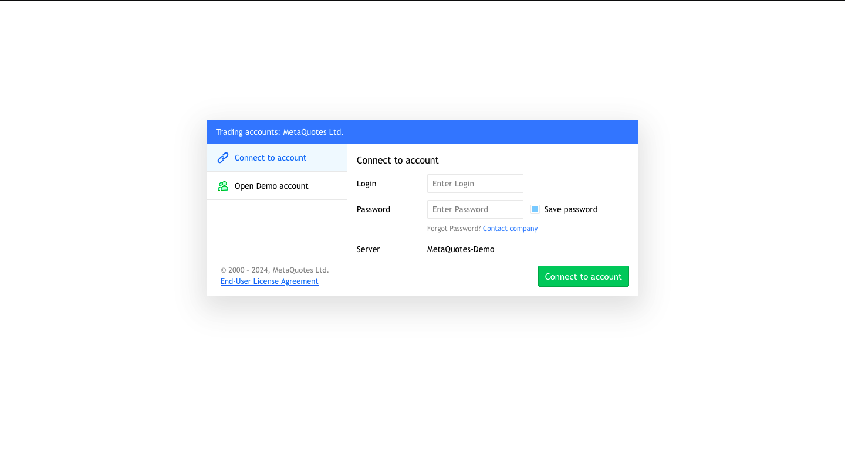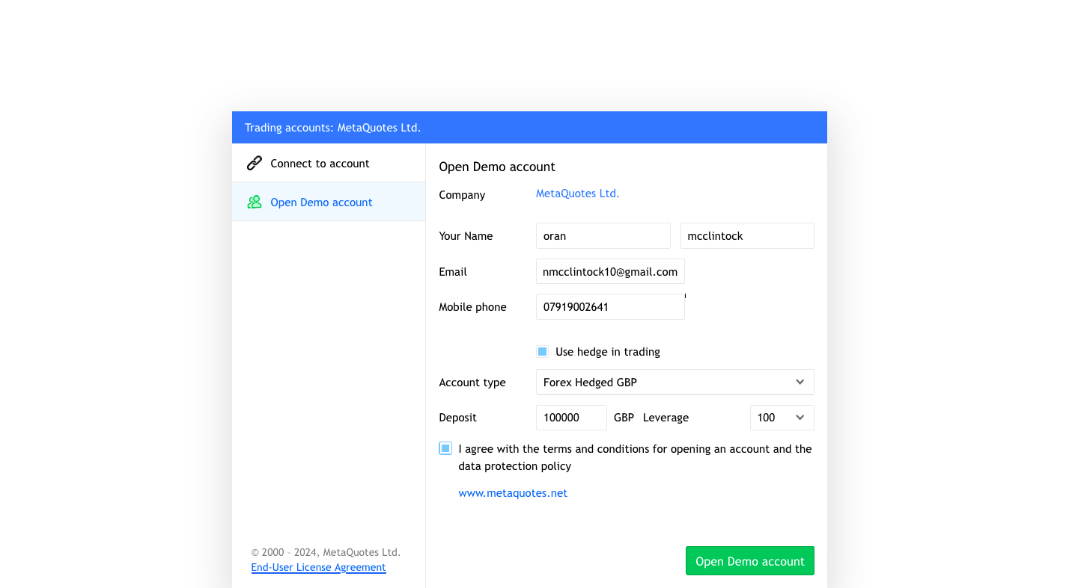

[Fig9]

Displayed above is Meta Trader 5 login form that customers use to create an account on the platform. I would like my system to be similarly structured to this as it is very user-friendly.

This system is user-friendly and looks professional. I would like to replicate this idea in my system to ensure that my system looks professional and modern.

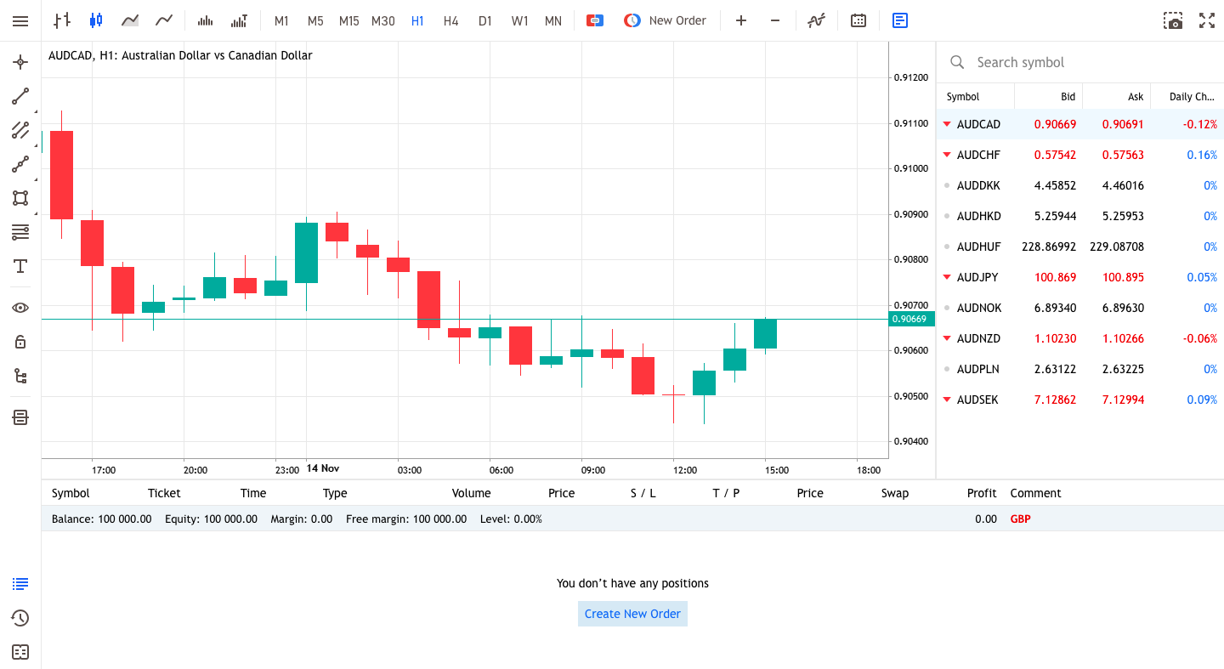

[Fig9]

After I logged onto the system as a customer, with my first name, surname, email, and phone number, I specified the amount I was depositing as well as my leverage. The form then changed to display the main page, as shown above. This system is user-friendly as it is clear what inputs should be made. From this, I know the inputs I need for my customer records, as all my competitors include them in their forms. In addition, this form uses dropdown boxes to make the customer choose from a set of options. This is another feature I could incorporate into my system, as it may simplify data input and ensure data is formatted correctly.

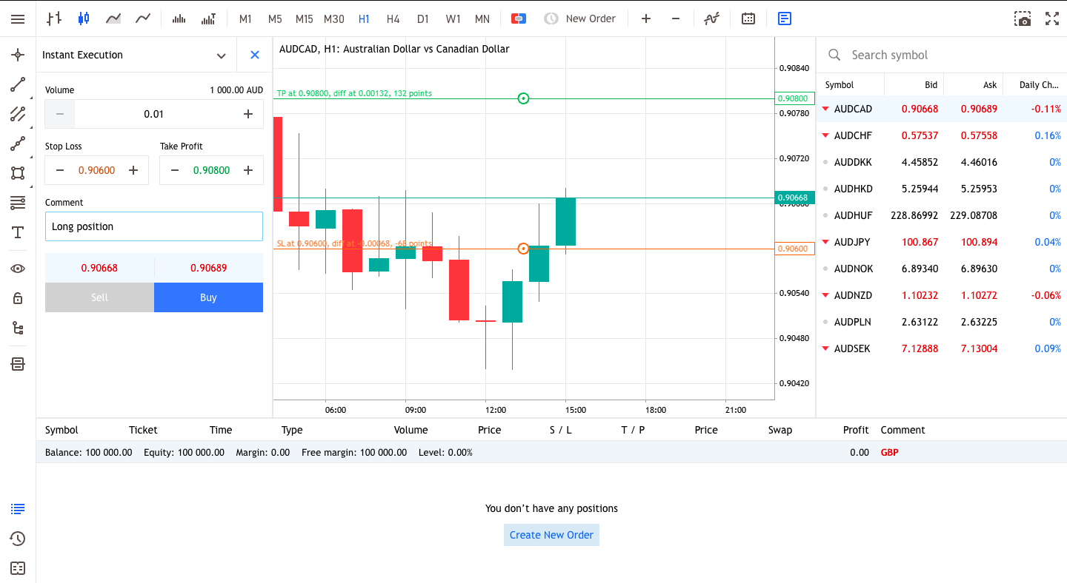

[Fig10]

[Fig11]

Above is an example of a digitalized version of the current file management system. Instead of staff manually taking down customer orders with data inputs such as volume, stop loss, take profit, comment, and buy/sell, customers can input these details into the system, which automatically carries out the trade for them. The system securely stores the information in a database that is easily retrievable.

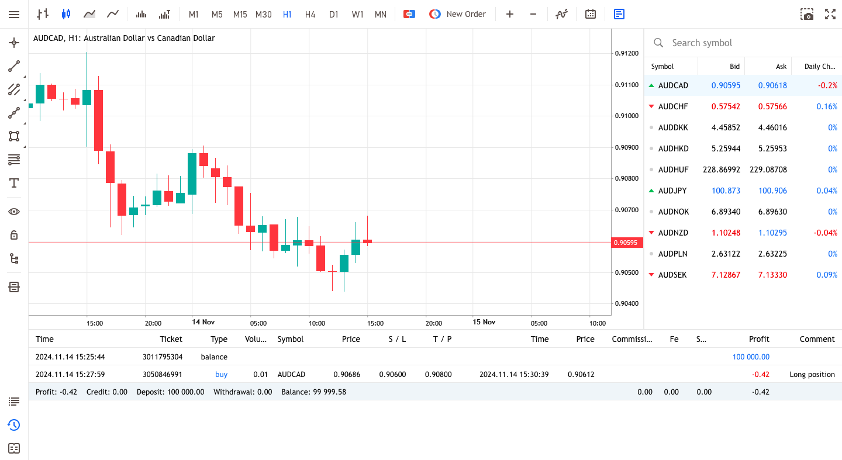

[Fig12]

The system displays trade history in a table format at the bottom of the screen, providing a clear overview of each trade's details. Each row includes information on the time, ticket number, trade type (e.g. buy), volume, symbol (e.g. AUDCAD), price, stop loss, take profit, profit, and any comments associated with the trade. This organized layout allows users to quickly review their trading actions and account adjustments, tracking performance metrics like profit and balance changes.

**Requirements of Stakeholders (Users) for the Proposed System**

* Customers should be able to:
  + Easily navigate the trading interface, ensuring a seamless process for placing orders and viewing account information.
  + Receive instant confirmation and feedback on their trades, providing a streamlined and transparent experience.
  + View, modify, or cancel their trades to manage their investment preferences effectively.
  + Trust that their personal and financial information is secure, against unauthorized access.
* Employees should have access to:
  + Accurate customer records and trade details, enabling efficient support and management of accounts.
  + An interface to review key information on customer trades, account statuses, and relevant transaction details.
  + Secure access to the system, ensuring that only authorized employees can access sensitive data.

**Specification**

The proposed system aims to replace the current paper-based trading management with a digital system, enhancing efficiency, accuracy, and data security. Key components include user interfaces for trade management, a secure database, and robust user authentication protocols. I propose using Python for development, leveraging SQL for database management and custom Tkinter for creating an intuitive GUI.

The system should allow the business to register new customers, manage trade records, and provide different access levels for admins and standard users. The graphical interface will be designed to be user-friendly, allowing employees and customers to easily navigate and utilize the application.

The success criteria for this project include improved data security, enhanced operational efficiency, and positive user feedback, which can be measured through customer surveys and system performance evaluations.

**Technical Justification**

The system will require an intuitive, user-friendly interface, a reliable database for storing customer and trade data, and seamless data extraction and display functionality. Key technical requirements include:

* **Labels** – To provide prompts, information displays, and guidance for users, ensuring a clear user experience on the GUI.
* **Buttons** – To allow users to save, modify, or retrieve trade data from the database. Buttons will also enable easy navigation between different sections of the system.
* **Entry Boxes** – To capture user inputs, such as customer name, contact information, and trade details. These fields will support data entry for customer records and facilitate trade searches by employees.
* **Dropdown Menus** – To provide pre-set options for data entry, such as trade types and order preferences, ensuring consistency in data formatting.
* **Colour and Visual Elements** – To enhance the visual appeal and modernity of the application, making the interface engaging and easy to use.

This system will be designed to run on MacOS as that is my current operating system as it is streamlined, quick and efficient and will easily be able to handle this lightweight trading application.